Lesson

LibGDX Multiplayer

Server:  
Contains an array of players with their location and IDs  
Client:  
Contains a list of all connected players  
Communication using WebSockets

Built using Node.JS and Socket.IO

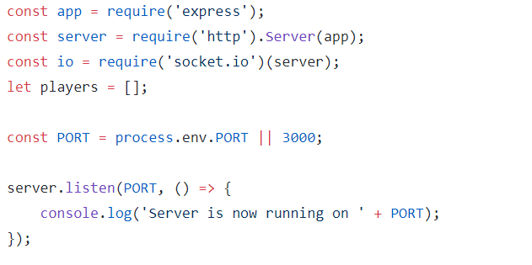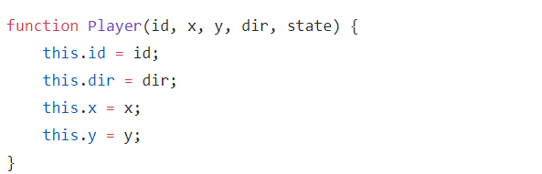

Handling player connections

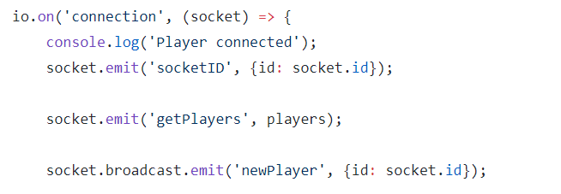

Handling server events

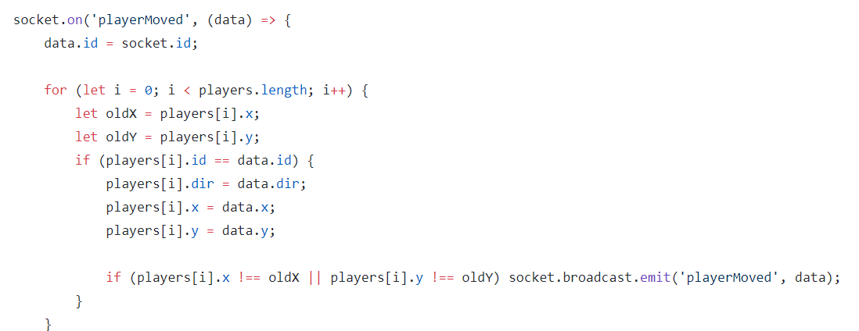

Handling player disconnects

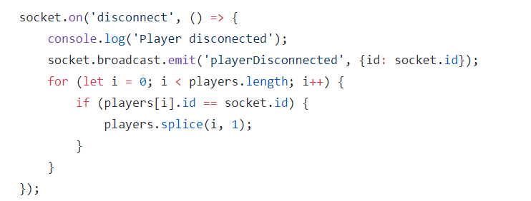

Adding the Socket.IO library to the client

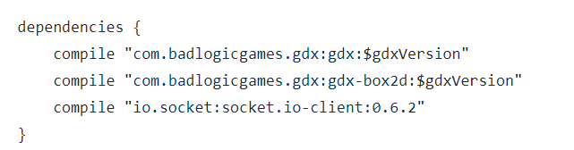

Setting up our WebSocket

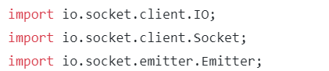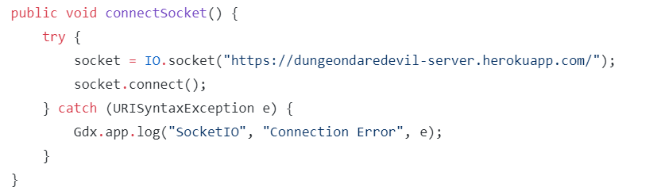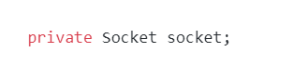

Upon connecting to the server

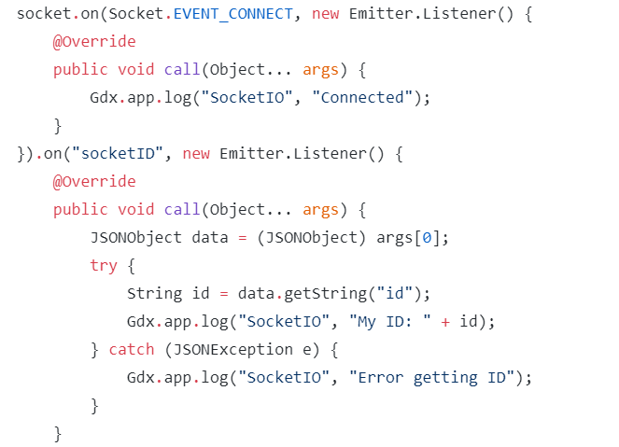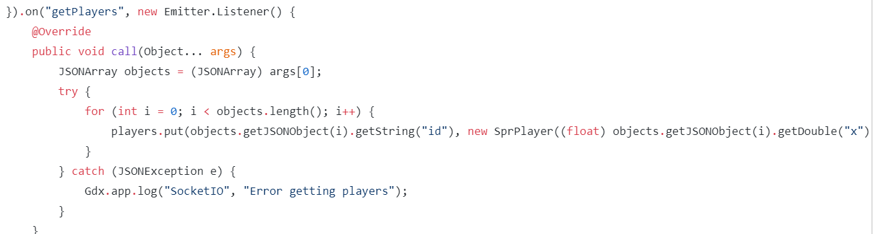

Handling players joining and leaving

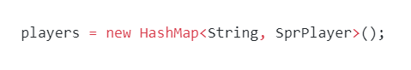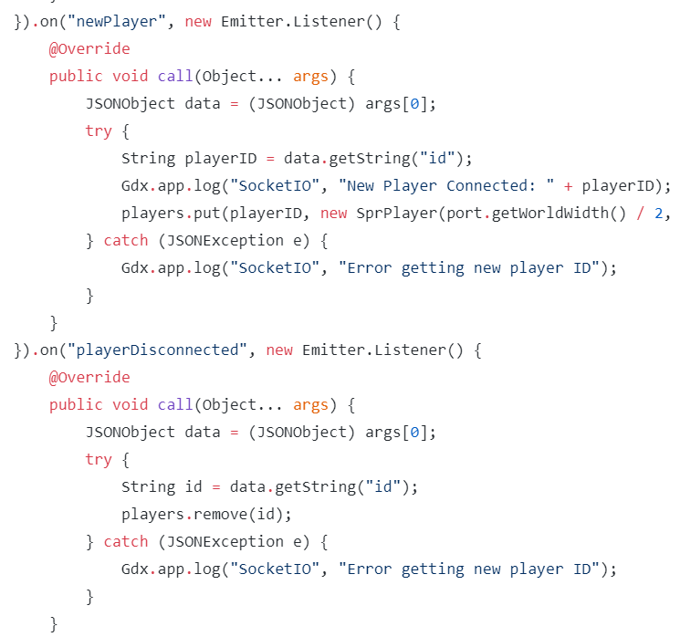

Handling multiplayer movement

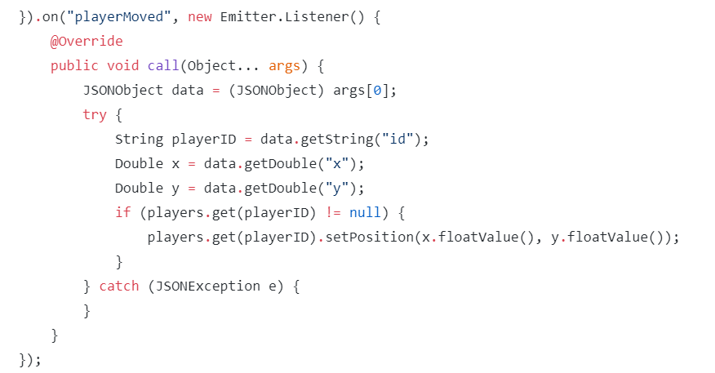

Syncing up player location with server

